
Job Description and Person Specification

Assistant Educational Psychologist - Childrens Services Directorate
Salary: | £37265 - £41616
Scale: | Soulbury Assistant EP Scale 2 – 5.
Working hours: | 37 Hours Full Time - Permanent
Work base: | Based in Kettering for work across North Northamptonshire
Responsible to: | Senior Educational Psychologist

We are delighted that you are considering joining our team at North Northamptonshire Council.
By recognising that our employees are our greatest asset, we invest in, value and develop them to progress our ambition to be an employer of choice. Our corporate values and behaviours also encourage customer focus, efficiency and support our employees to achieve.
Main Purpose
- To support the Educational Psychology Service (EPS) to deliver a psychological based service through a consultation model, observation and assessment, intervention, training, research, and development work.
- To support the improvement of outcomes for children through working directly with individuals and groups of children, parents and carers, schools and other educational providers, including early years settings, the local authority and partner agencies.
- To gain experience, skills, knowledge and understanding of the role and professional practice of educational psychologists, in preparation for formal post-graduate training in educational psychology.

All duties undertaken will be subject to supervision by an appropriately qualified educational psychologist. The duties and responsibilities allocated to the post holder will depend upon their knowledge, skills, and experience at the time, as judged by their supervisors and managers, and the needs of the service at the time of being in the post. The post holder may be required to undertake any or all of the following duties as considered appropriate to their capability, under such level of supervision as may be deemed necessary by their supervisors: -
Role Responsibilities
- To assist the EPS in the delivery of core and traded services. This will include early intervention work in schools, early years, and other settings, to support others to overcome barriers to learning and to promote the social and emotional wellbeing of children and young people (0-25 years of age).
- To undertake a range of consultations, observations, evidence-informed assessment, and intervention activities, in relation to special educational needs/disabilities (SEND).
- To carry out EPS support tasks as identified by supervising EPs, including assisting others to provide Psychological Advice for children undergoing an Education, Health and Care Needs Assessment.
- To deliver longer term interventions: both to complement and to work alongside staff with children and their families, including group work as appropriate. This may include therapeutic interventions.
- To assist EPs in the delivery of training and professional development for school staff and other professional groups, and training for parents/carers of children and young people.
- To deliver evidence-informed practice within the knowledge framework of the profession of educational psychology, with due regard to the relevant legislative framework in relation to the education of children and young people who have or may have SEND.
- To promote the active participation of children, young people and their families in activities and approaches focused on supporting life outcomes appropriate to individual aspirations.
- To assist in research and evaluation activities, including the collection, analysis, and maintenance of data and in the production of information for a range of purposes.
- To assist in the development of resources, leaflets, newsletters, webinars, etc. to promote the work of the EPS.
- To support the service in some back-office tasks, e.g. in relation to making, organising and maintaining of resources.
- To keep accurate and timely records of all contacts and work relating to children, young people, and their families in accordance with service protocols.
- To be part of a team and engage in and contribute to service meetings and CPD.
- To engage in regular supervision (an equivalent of 30 mins per day minimum) – a mix of group and individual supervision and reflect on practice.
- To keep up to date with current understanding, research, and practice in relation to educational psychology, which will enable the post holder to develop a range of knowledge, experience, and skills in preparation for training as an educational psychologist.
- To develop an awareness and understanding of equal opportunities and culturally responsive practice.
- To ensure policies and procedures with regards to the safeguarding of children and young people and vulnerable adults across North Northamptonshire are always followed: in order to promote the welfare of children as described by Northamptonshire Safeguarding Children Partnership (NSCP).
- To always work within local authority guidelines and policies and those provided by professional Codes of Conduct of the Association of Educational Psychologists (AEP) and the British Psychological Society (BPS).

These principal responsibilities reflect the major tasks to be carried out by the post holder and identify a level of responsibility at which they will be required to work. In the interests of effective working, the major tasks may be reviewed from time to time to reflect changing needs and circumstances. Such reviews and any consequential changes will be carried out in consultation with the post holder.

Person Specification
Qualifications
Essential
- 1st or 2:1 Bachelor’s degree in psychology or an equivalent qualification recognised by the British Psychological Society (BPS) as conferring the Graduate Basis for Membership.

Desirable

- Qualification as a teacher recognised within the UK – any subject, any age range.
- Any other children’s services qualification relevant to the delivery of children’s services, e.g., early years, social work, or youth work.

Background and Experience
Essential
- Sound knowledge of applied psychology as relevant to working with children and young people, appropriate to their level of development, within the context of school systems and the legislative framework for SEND.
- Practical experience of working in education settings with children and young people (at least one year of paid or voluntary work), e.g., as a teacher, teaching assistant or equivalent role for local authority support services, such as social work, sport and/or youth services.
- Experience of planning, leading, and delivering targeted individual and group interventions for children and young people.
Desirable
- Successful organisation and delivery of further professional development to teachers and others responsible for children.
- Experience of working directly with children and young people who present with differences that may negatively impact on their development and / or who have additional social, emotional, and mental health needs.
- Awareness of the impact of positive and negative early childhood experiences on later development and learning.
- Knowledge of cycles of deprivation and the impact exclusion can have on life chances for children and young people.
- Knowledge of emotionally based school avoidance.
- Knowledge of child protection and safeguarding practices.

Ability and Skills
Essential
- Ability to: work collaboratively within a multi-professional team; engage positively with children and young people and to elicit their voice; and work with parents/carers as partners, particularly families under stress
- Ability to recognise own strengths and areas in need of further development, and so where appropriate work independently or seek supervision and support.
- Ability to communicate clearly and concisely, orally and in writing.
- Proficient in using ICT software packages such as MS Office, email, databases, and spreadsheets, and to ability to communicate clearly and concisely, orally and in writing.
- Ability to travel to different locations, including providing home-visits when required (with LA safety protocols); hold a UK driving licence; and have use of a car.

Desirable

- The ability to undertake research activities and apply the outcomes to guide good practice.
- Competence in presentation skills.

Commitment
Commitment to apply for doctoral educational psychology studies within 2 years of starting work as an assistant educational psychologist with North Northamptonshire Council.
Equality
Essential
- Knowledge of equal opportunities and equity, including legislative framework and culturally responsive practice; and commitment towards tackling inequality and exclusion within our schools and communities.

Mental Demands of the role
Essential
- Enthusiasm for working with children and young people and their families; and for working effectively with multi-agency colleagues.
- Ability to prioritise and manage workloads and accommodate change; and to maintain high levels of professional and personal integrity.

Accountability / Autonomy
The assistant educational psychologist will be accountable to a senior or specialist senior educational psychologist for maintaining a high professional standard in the delivery of all aspects of their work. Within this accountability the assistant educational psychologist will make their own professional decisions based on evidence, knowledge of relevant research and with reference to guidance set by local authority policies.
Our Values and Behaviours
Our values define who we are and how we operate, by forming the foundation for how we interact with our customers, colleagues and provide our services. They are also at the forefront of our decision making and delivery and include:
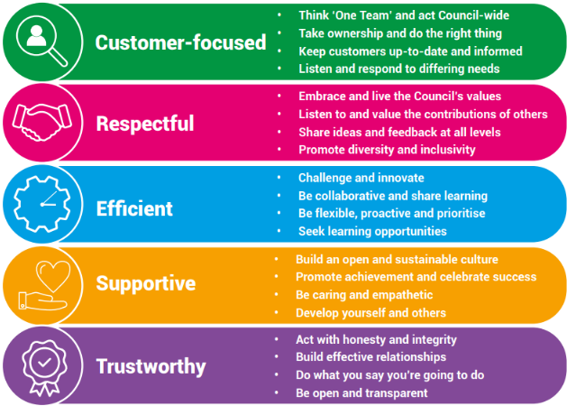

Our Key Commitments
Our key commitments help ensure that the priorities we make, now and in the future, maintain the necessary breadth of focus in those areas that we believe matter most.
Our key commitments are:
- Active, fulfilled lives: We will help people live healthier, more active, independent and fulfilled lives.
- Better, brighter futures: We will care for our young people, providing them with a high-quality education and opportunities to help them flourish.
- Safe and thriving places: We will enable a thriving and successful economy that shapes great places to live, learn, work and visit.
- Green, sustainable environment: We will take a lead on improving the green environment, making the area more sustainable for generations to come.
- Connected communities: We will ensure our communities are connected with one another, so they are able to shape their lives and the areas where they live.
- Modern public services: We will provide efficient, effective and affordable services that make a real difference to all our local communities.

Why choose us?

We offer a fantastic working environment including diverse and active staff networks, great flexible working opportunities and well as many other benefits, you will:

- Receive a generous annual leave allowance.
- Have access to our Employee Assistance Programme which offers a confidential service for employees and their families 24 hours a day / 7 days a week. The programme provides expert advice and counselling in areas such as finances, family and personal problems, work issues, health related problems, childcare and consumer rights.
- Join the Local Government Pension Scheme (LGPS), which is a tax approved occupational pension scheme with a generous employer contribution rate, immediate life cover and ill-health protection. Benefits are based on the length of your membership and final salary.

We are proud to be a recognised Disability Confident Employer and is committed to providing an inclusive recruitment process and will offer an interview to disabled applicants who meet the essential criteria for the role.


