Assessment & Enablement Worker
Salary: | £34,434 - £36,363
Pay Band: | NNCBAND05
Working Hours: | 37 hours per week
Service Area: | Adult Social Care
Responsible to: | Principal Social Worker/Principal Care Manager

Main Purpose
To support customers, their families and carers to retain/or regain independence.

Carry out strength-based assessments in accordance with the Care Act 2014, working in partnership with key providers in the community to enable service users to access local services.

Role Responsibilities
- Undertake clear and accurate statutory assessments and reviews of an individual in line with statutory guidance and best practice. Provide appropriate responses in situations which may be ambiguous and/or difficult, and use analytical skills to influence and inform assessment, decision making and interventions to deliver outcomes that best meet the customer need.
- Provide short term intervention plans for individuals as appropriate, ensuring individuals are supported and encouraged to access community support that is available, acquiring knowledge about different groups, races and cultures and needs which informs service delivery and understands the impact on customers.
- Effectively assess and manage risk, for example safeguarding and take appropriate action when required including supporting safeguarding investigations under the direction of a manager, social worker or other lead professional.
- Act as the lead professional provide support to enable the customer to achieve a reasonable degree of independence and autonomy, where a person is constrained by social or family circumstance.
- Use a person-centred approach, listening and developing creative and personalised solutions to assist people to manage their lives independently for as long as possible. Work in partnership to improve collaboration, co-ordination and support to achieve and meet customer needs.
- Provide accurate, impartial information, support and guidance to customers and their families, including appropriate information relating to financial matters, ensuring any implementation of a support plan is within budgetary constraints.
- Provide written and verbal reports, appropriate for legal purposes, which are concise, informative and based on evidence to support problem solving and resolution.
- To manage own caseload and organise and plan work activities taking into account the need to prioritise tasks and responsibilities, to ensure assessments and reviews, support plans are undertaken and updated within an agreed timeframe.
- To maintain case records where the information is concise, accurate and timely so that customers circumstances are accessible at all times to ensure continuity of provision, maintaining this customer and management information through the use of appropriate IT systems and in line with professional requirements and departmental recording methods.

Carry out any other duties which fall within the broad spirit, scope and purpose of this job description and which are commensurate with the grade of the post.

Safeguarding Commitment
We are committed to safeguarding and promoting the welfare of children and young people/vulnerable adults. We require you to understand and demonstrate this commitment.

Person Specification – Assessment & Enablement Worker

Qualifications
- NVQ III or equivalent or the ability to evidence and demonstrate on the job experience working at this level in Health and Social care/Social Care related subject.
- 3 A levels or equivalent.
- GCSE grade C and above or equivalent in Maths & English.

Background and Experience
- Working knowledge and experience in understanding needs of vulnerable adults.
- Working knowledge of the Care Act 2014.
- Working knowledge and understanding of relevant national and local policy issues in Adult Social Care.
- Knowledge & understanding of cultural differences where communities have different ethnic backgrounds to ensure equality of opportunity.
- Previous experience of working with vulnerable adults.
- Experience of working in multi-agency environments.
- Experience of using IT packages.

Ability & Skills
- Excellent report writing skills, demonstrating the ability to achieve clear and concise reports that are fit for purpose.
- Excellent listening skills and the ability to understand and communicate clearly at all levels.
- Ability to build a rapport and build relationships with customers and their families.
- Ability to prioritise tasks, manage own workload and be accountable for case work.
- Ability to actively support and promote equal opportunities.
- Ability to operate in a fast pace, changing environment.
- Empathetic and caring when working with people.
- Ability to create close working contacts in the community to support customers and their families.
- Ability to work from various locations and travel countywide.

Equal Opportunities
Ability to demonstrate awareness/understanding of equal opportunities and other people’s behaviour, physical, social and welfare needs.

Safeguarding
Demonstrate an understanding of the safe working practices that apply to this role.
Ability to work in a way that promotes the safety and well-being of children and young people/vulnerable adults.

Health & Safety
Ensure that reasonable care is taken at all times for the health, safety and welfare of yourself and other persons, and to comply with the policies and procedures relating to health and safety within the department.

Disclosure Level
What disclosure level is required for this post?
☐ None ☐ Standard ☐ Enhanced ☒ Enhanced with barred list checks

Our Values and Behaviours
Our values define who we are and how we operate, by forming the foundation for how we interact with our customers, colleagues and provide our services. They are also at the forefront of our decision making and delivery and include:
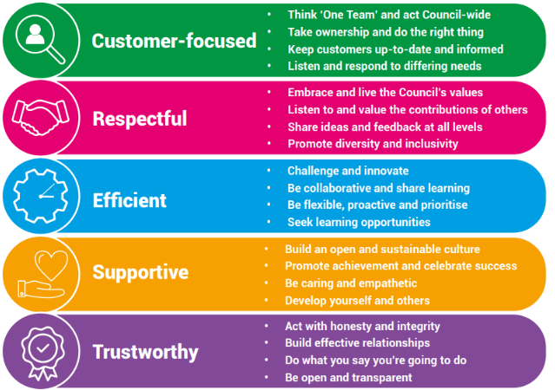

Our Key Commitments
Our key commitments help ensure that the priorities we make, now and in the future, maintain the necessary breadth of focus in those areas that we believe matter most.

Our key commitments are:

- Active, fulfilled lives: We will help people live healthier, more active, independent and fulfilled lives.
- Better, brighter futures: We will care for our young people, providing them with a high-quality education and opportunities to help them flourish.
- Safe and thriving places: We will enable a thriving and successful economy that shapes great places to live, learn, work and visit.
- Green, sustainable environment: We will take a lead on improving the green environment, making the area more sustainable for generations to come.
- Connected communities: We will ensure our communities are connected with one another, so they are able to shape their lives and the areas where they live.
- Modern public services: We will provide efficient, effective and affordable services that make a real difference to all our local communities.

Why choose us?
We offer a fantastic working environment including diverse and active staff networks, great flexible working opportunities and well as many other benefits, you will:

- Receive a generous annual leave allowance.
- Have access to our Employee Assistance Programme which offers a confidential service for employees and their families 24 hours a day / 7 days a week. The programme provides expert advice and counselling in areas such as finances, family and personal problems, work issues, health related problems, childcare and consumer rights.
- Join the Local Government Pension Scheme (LGPS), which is a tax approved occupational pension scheme with a generous employer contribution rate, immediate life cover and ill-health protection. Benefits are based on the length of your membership and final salary.

We are proud to be a recognised Disability Confident Employer and is committed to providing an inclusive recruitment process and will offer an interview to disabled applicants who meet the essential criteria for the role.



