Commissioning and Contracts Manager
Salary: | £55,224 – 58,680
Pay Band: | NNBAND09
Working Hours: | 37 hours per week
Service Area: | Children’s Services
Responsible to: | Head of Service for Commissioning & Contracts

Main Purpose
To lead the commissioning, procurement, market management and contract oversight of services for children and young people aged 0–25. The postholder will ensure services are high-quality, outcome-focused, cost-effective, and aligned with local needs and statutory requirements. The role supports the commissioning and development of family support, early intervention and integrated community services within the wider children and families portfolio.

Reporting to the Head of Service for Commissioning and Contracts for a specific market, the post holder is responsible for the development, implementation, and management of the commissioning and contractual aspects of all relevant contracts within their market area, in line with the service strategy.

To ensure the development of high-quality evidence-based services which meet identified local needs in line with nationally and locally agreed strategic priorities and deliver value for money.

This role aligns the contract and commissioning functions to ensure that every contract is meaningful, outcomes-based, and value-for-money.

Supporting the development of joint commissioning strategies to develop and improve services across the Children’s Directorate. The key objectives are:
- Development of multi-agency strategies to inform decisions about the future shape of services, both statutory and non-statutory, in order to meet the needs of Children across North Northamptonshire
- Robust needs analysis of local population.
- Mapping of existing service provision with identification of service gaps
- Procurement of services with a clear service specification of what needs to be provided to meet the service outcomes
- Contract Management and review of contracts with associated Key Performance Indicators (KPIs) and performance monitoring arrangements in place
The postholder plays a key role in supporting the development of provision and services across a complex and high-pressure system with rising demand, national reforms, and significant financial challenges. The Commissioning Manager is central to:
- supporting the delivery and development of the Family Hubs model and associated services
- developing integrated pathways and partnerships to improve outcomes for children, young people and families
- supporting transformation and sustainability across early help and family support services
- ensuring effective, lawful and efficient commissioning, contract management and performance oversight of Family Hubs and related provision

The role requires cross-agency working, strategic thinking and the ability to translate evidence into commissioning decisions.

Role Responsibilities
- Inform multi-agency commissioning strategies that reflect local need, system priorities, statutory responsibilities and national reforms.
- Undertake comprehensive needs analysis and use data, intelligence and forecasting to inform commissioning plans, market shaping, and sufficiency activity.
- Lead market management for provision, including mapping supply, identifying gaps, developing provider relationships, and contributing to sufficiency plans that reduce reliance on high-cost placements.
- Lead procurement activity for services, including specification development, tendering, evaluation, commercial negotiation and award processes, ensuring compliance and value for money.
- Strengthen contract management and quality assurance frameworks, ensuring providers deliver safe, effective and outcome-focused services aligned to contractual requirements.
- Support annual fee uplift negotiations with Independent and non-maintained special schools, providing evidence-based recommendations to senior leaders.
- Ensure co-production with children, young people and families, and meaningful partnership working with Education, Social Care, Health, NCT, ICB, providers and regional partners.

Carry out any other duties which fall within the broad spirit, scope and purpose of this job description and which are commensurate with the grade of the post.

Supervision & Work Planning

The postholder manages their own workload and sets priorities within agreed programmes and governance. They will:

lead projects and programme activity

report progress, risks and issues to the Head of Commissioning & Contracts

participate in monthly oversight meetings and ad-hoc supervision

work with autonomy within defined commissioning and procurement frameworks

Safeguarding Commitment
We are committed to safeguarding and promoting the welfare of children and young people/vulnerable adults. We require you to understand and demonstrate this commitment.

Person Specification - Commissioning and Contracts Manager
ATTRIBUTES | ESSENTIAL CRITERIA | DESIRABLE CRITERIA
Education and Qualifications | Degree, professional qualification, or equivalent level of experience in commissioning, early help, education, social care, or a related field.  Knowledge of commissioning and contract management frameworks relevant to children’s services/family help/early help | Evidence of continuing professional development.  Formal commissioning, project management or procurement training (e.g., CIPS, APM, PRINCE2).
Experience and Knowledge | Knowledge and understanding of risk assessment, managing risks, and taking appropriate mitigating actions.  Knowledge of Information Governance, Data Protection, and the ability to embed these within service delivery.  Experience commissioning services in  Family based models  Experience in developing and implementing commissioning strategies and leading procurement activity. | Experience of working within statutory frameworks  Experience of working within multi-agency safeguarding or governance frameworks.
Ability and Skills | Practical, legal and procedural understanding of contractual compliance, performance issues and safeguarding.  Advanced skills relevant to commissioning and contract management (e.g., regulatory frameworks, commercial negotiation, contract law principles).  Ability to work with partners to set direction, influence change and support system leadership.  Ability to develop and sustain collaborative relationships with internal and external partners, ensuring effective engagement and communication.  Ability to analyse complex information, identify issues and develop evidence-based solutions.  Ability to interpret data, prioritise, and review performance against targets.  Excellent communication and persuasion skills, including negotiation, partnership working and report writing.  High level of political awareness, integrity and professional judgement.  Strong ICT skills, including confident use of commissioning, data or contract-management systems. | Experience advising on contractual models and developing specifications, quality metrics and performance frameworks.  Experience supporting or managing teams, including prioritising workloads and achieving deadlines through others.  Experience of managing budgets or contributing to financial planning and value-for-money reviews.  Experience engaging with SEND providers, schools, trusts or voluntary sector organisations.
Additional Factors | Ability to demonstrate awareness and understanding of equality, diversity and the needs of children, young people and families.  Ability to travel for meetings and provider engagement as required. | Full driving licence (if required for the post).

Equal Opportunities
Ability to demonstrate awareness/understanding of equal opportunities and other people’s behaviour, physical, social and welfare needs.

Safeguarding
Demonstrate an understanding of the safe working practices that apply to this role.
Ability to work in a way that promotes the safety and well-being of children and young people/vulnerable adults.

Health & Safety
Ensure that reasonable care is taken at all times for the health, safety and welfare of yourself and other persons, and to comply with the policies and procedures relating to health and safety within the department.

Disclosure Level
What disclosure level is required for this post?
☒ None ☐ Standard ☐ Enhanced ☒ Enhanced with barred list checks

Our Values and Behaviours
Our values define who we are and how we operate, by forming the foundation for how we interact with our customers, colleagues and provide our services. They are also at the forefront of our decision making and delivery and include:
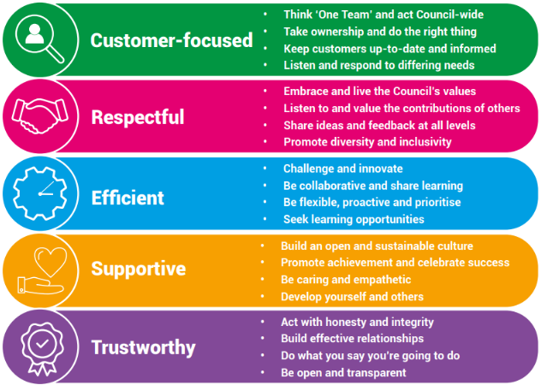

Our Key Commitments
Our key commitments help ensure that the priorities we make, now and in the future, maintain the necessary breadth of focus in those areas that we believe matter most.

Our key commitments are:

- Active, fulfilled lives: We will help people live healthier, more active, independent and fulfilled lives.
- Better, brighter futures: We will care for our young people, providing them with a high-quality education and opportunities to help them flourish.
- Safe and thriving places: We will enable a thriving and successful economy that shapes great places to live, learn, work and visit.
- Green, sustainable environment: We will take a lead on improving the green environment, making the area more sustainable for generations to come.
- Connected communities: We will ensure our communities are connected with one another, so they are able to shape their lives and the areas where they live.
- Modern public services: We will provide efficient, effective and affordable services that make a real difference to all our local communities.

Why choose us?
We offer a fantastic working environment including diverse and active staff networks, great flexible working opportunities and well as many other benefits, you will:

- Receive a generous annual leave allowance.
- Have access to our Employee Assistance Programme which offers a confidential service for employees and their families 24 hours a day / 7 days a week. The programme provides expert advice and counselling in areas such as finances, family and personal problems, work issues, health related problems, childcare and consumer rights.
- Join the Local Government Pension Scheme (LGPS), which is a tax approved occupational pension scheme with a generous employer contribution rate, immediate life cover and ill-health protection. Benefits are based on the length of your membership and final salary.

We are proud to be a recognised Disability Confident Employer and is committed to providing an inclusive recruitment process and will offer an interview to disabled applicants who meet the essential criteria for the role.



