Social Worker
Salary: | £42,839 - £46,142
Pay Band: | NNCBAND07
Working Hours: | 37 hours per week
Work Base: | William Knibb Centre, Kettering
Responsible to: | Principal Social Worker/Principal Care Manager

Main Purpose
To provide a high standard of social work to people arising out of the Adult Social Care (ASC) duties and powers under legislation and in accordance with divisional and area policy, procedures, guidelines and the standards for all social workers registered with Social Work England.

Role Responsibilities
- Act as “trusted assessors” for defined areas of the support plan Conduct or support individual assessments (including risk assessments of both the customer and carer, in line with eligibility criteria to assess the dependency needs of the customer) or facilitate self-assessments, using the appropriate assessment tools and techniques in order to establish clear, relevant, proportionate, cost effective and appropriate options for the individual. Value and encourage the contribution of service users and their advocates, relatives, carers and support workers where appropriate. Work alongside Brokers to procure support plans including equipment and adaptations.
- To manage and be accountable for an allocated caseload of customers in compliance with statutory requirements, local policy, professional best practice and with regard for individual choice. Ensure compliance with policies and procedures of the council, and those of any partner agencies, are followed, and that the service is always delivered in accordance with professional standards, policy and practice and within the relevant statutory and regulatory frameworks.
- Operating within a multidisciplinary environment to provide appropriate, professional social work support for adults with additional care and support needs within the framework of the seven social care outcomes, adhering to the principles of the Care Act (2014) and, where applicable, Mental Capacity Act (2005) and Mental Health Act (1983; 2007).
- Operating within an integrated service, to provide individualised, outcomes-led, personalised support, based on structured, individual assessments that inform the setting up and commissioning of appropriate packages of support.
- Assist with monitoring and evaluating the effectiveness of the service and contribute to the development of service improvements through participation and involvement in local and central team meetings, supervision, training, conferences and other forums. Work flexibly and respond positively to changing business and customer needs. and carry out any other duties within the scope of the nature and grade of the post, as directed by the line manager
- Maintain up to date, accurate and timely records of communication, decisions, actions and outcomes relating to cases in line with the processes, standards and systems of adult social care. Take responsibility for the administrative processes associated with dealing with cases in accordance with service procedures, standards and targets. Produce, maintain and present accurate records and reports for court and audit purposes in accordance with relevant policies, procedures and legislation.

- Supervise and allocate work to Assessment and Enablement Workers (AEW’s) and less experienced colleagues to maximise the team’s abilities and effectiveness in meeting the challenges of the service.
- Take responsibility for promoting and safeguarding the welfare of people who come into contact with the service, in full compliance with local policies and procedures and that the principles are embedded in all practices, advice, decisions and support associated with this role.
- Liaise with, establish and maintain effective working relationships with other local services, specialist teams, Hospital Trusts, and the 3rd sector organisations relevant to the needs of the customer in order to deliver a holistic and seamless service. Co-ordinating and leading multidisciplinary/ professional meetings as required, representing the service at internal and external meetings.

Carry out any other duties which fall within the broad spirit, scope and purpose of this job description and which are commensurate with the grade of the post.

Safeguarding Commitment
We are committed to safeguarding and promoting the welfare of children and young people/vulnerable adults. We require you to understand and demonstrate this commitment.

Person Specification – Social Worker

Qualifications
- Degree of Equivalent Social Work/CQSW/DipSW.
- Registered Social Worker with Social Work England.

Background and Experience
- Knowledge of relevant legislation appropriate to working with vulnerable adults is essential.
- Understanding forms of harm and their impact on people, and the implications for practice, drawing on concepts of strength, resilience, vulnerability, risk and resistance, and apply to practice.
- Critical understanding of the range of theories and models for social work intervention with individuals, families, groups and communities, and the models derived from them.
- Acknowledgment of the centrality of relationships for people and the key concepts of attachment, separation, loss, change and resilience.
- Can demonstrate training toward being an Approved Mental Health Professional (AMHP).
- Application of appropriate legal frameworks and guidance that inform and mandate social work practice.
- Understanding and using knowledge relating to your area of practice, including critical awareness of current issues and new evidence-based research.
- Experience in working with customer groups for example Mental Health, Older Persons, Learning Disability, Transitions and Physical disabilities.
- Using assessment procedures discerningly so as to inform judgement. Clearly & accurately reporting and recording analysis and judgements.
- Confident and effective judgement about risk and accountability in decision making.

Ability & Skills
- The ability to effectively use IT systems appropriate to the job requirements.
- Managing workload independently, seeking support and suggesting solutions for workload difficulties.
- Engaging effectively with people in complex situations, both short term and building relationships over time.
- Ability to independently travel (I.e. full driver's licence).

Equal Opportunities
Ability to demonstrate awareness/understanding of equal opportunities and other people’s behaviour, physical, social and welfare needs.

Safeguarding
Demonstrate an understanding of the safe working practices that apply to this role.
Ability to work in a way that promotes the safety and well-being of children and young people/vulnerable adults.

Health & Safety
Ensure that reasonable care is taken at all times for the health, safety and welfare of yourself and other persons, and to comply with the policies and procedures relating to health and safety within the department.

Disclosure Level
What disclosure level is required for this post?
☐ None ☐ Standard ☐ Enhanced ☒ Enhanced with barred list checks

Our Values and Behaviours
Our values define who we are and how we operate, by forming the foundation for how we interact with our customers, colleagues and provide our services. They are also at the forefront of our decision making and delivery and include:
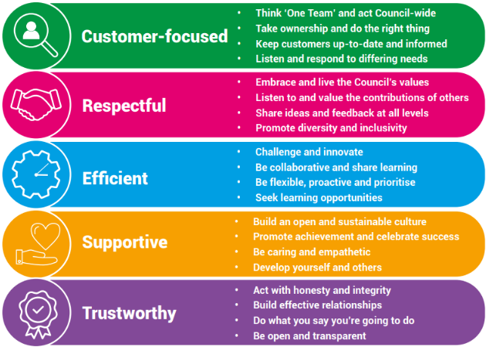

Our Key Commitments
Our key commitments help ensure that the priorities we make, now and in the future, maintain the necessary breadth of focus in those areas that we believe matter most.

Our key commitments are:

- Active, fulfilled lives: We will help people live healthier, more active, independent and fulfilled lives.
- Better, brighter futures: We will care for our young people, providing them with a high-quality education and opportunities to help them flourish.
- Safe and thriving places: We will enable a thriving and successful economy that shapes great places to live, learn, work and visit.
- Green, sustainable environment: We will take a lead on improving the green environment, making the area more sustainable for generations to come.
- Connected communities: We will ensure our communities are connected with one another, so they are able to shape their lives and the areas where they live.
- Modern public services: We will provide efficient, effective and affordable services that make a real difference to all our local communities.

Why choose us?
We offer a fantastic working environment including diverse and active staff networks, great flexible working opportunities and well as many other benefits, you will:

- Receive a generous annual leave allowance.
- Have access to our Employee Assistance Programme which offers a confidential service for employees and their families 24 hours a day / 7 days a week. The programme provides expert advice and counselling in areas such as finances, family and personal problems, work issues, health related problems, childcare and consumer rights.
- Join the Local Government Pension Scheme (LGPS), which is a tax approved occupational pension scheme with a generous employer contribution rate, immediate life cover and ill-health protection. Benefits are based on the length of your membership and final salary.

We are proud to be a recognised Disability Confident Employer and is committed to providing an inclusive recruitment process and will offer an interview to disabled applicants who meet the essential criteria for the role.



