Description and Person Specification
Establishment Control Officer
(salary band)

Purpose & Impact:

The purpose of the role is to work with Line managers, HR and Directors or WNC and all partners as part of the Lead authority model, to update and maintain the establishment and positions within the ERP system.

There is a requirement to assist and advise Line managers and HR on queries related to the Establishment within ERP and to work with Business systems to advise on and implement complex and large-scale changes related to TUPE and restructures.

Accountable to:

This role reports directly into the Payroll Manager. The Establishment team are part of the larger Payroll Services department which is part of the Corporate Services Directorate in West Northamptonshire Council

Responsibilities:

- Responsible for providing a high quality, customer focused administrative support service to all clients, including the maintenance of Client’s Establishment and related processes.

- Take ownership of queries and request from colleagues and service users in relation to changes to the line management, locations, cost codes, and hours, along with the creation of new positions as well as the deletion of old/out of use positions.
- Respond to and resolve service requests and queries ensuring operational service priorities are met through ownership, adhering to agreed service standards and according to operational procedures and ensuring that queries are fully investigate and resolved and that complaints are escalated in accordance with the relevant procedure.

- Provide advice and guidance on the impacts of requested changes and challenge requests where necessary to ensure that actions undertaken will achieve the desired outcome and minimise any potential adverse impacts for the service and the employee.

- Provide guidance and support to Line managers and HR with regards to the implementation of organisational restructures and TUPE and work with the Business Systems and Transactions teams to ensure that the process is completed efficiently and effectively.

- Manage own workload, processing high quality information/data accurately and in a timely manner. Ensuring agreed processes are followed ensure that audit requirements are adhered to, while also working within and supporting other members of the team with their workload, as required/directed.

- Work collaboratively with other payroll service teams to ensure all that cross-team impacts are managed and mitigated.

- Provide suggestions to the Payroll Manager and Service Delivery Manager on areas of the service where improvements could be made and make recommendations to improve processes and efficiency.

- Carry out any other duties which fall within the broad spirit, scope and purpose of this job description and which are commensurate with the grade of the post.

- Actively challenge and seek to eliminate any directly or indirectly discriminatory practice or behaviours.

- Demonstrate awareness/understanding of other people’s behavioural, physical, social and welfare needs. Ensure that reasonable care is taken at all times for the health, safety and welfare of yourself and other persons, to certify compliance with policies and procedures relating to health and safety within the service.

This job description reflects the major tasks to be carried out by the post holder and identifies a level of responsibility at which they will be required to work. In the interests of effective working, the major tasks may be reviewed from time to time to reflect changing needs and circumstances. Such reviews and any consequential changes will be carried out in consultation with the post holder.

Our Values& Behaviours
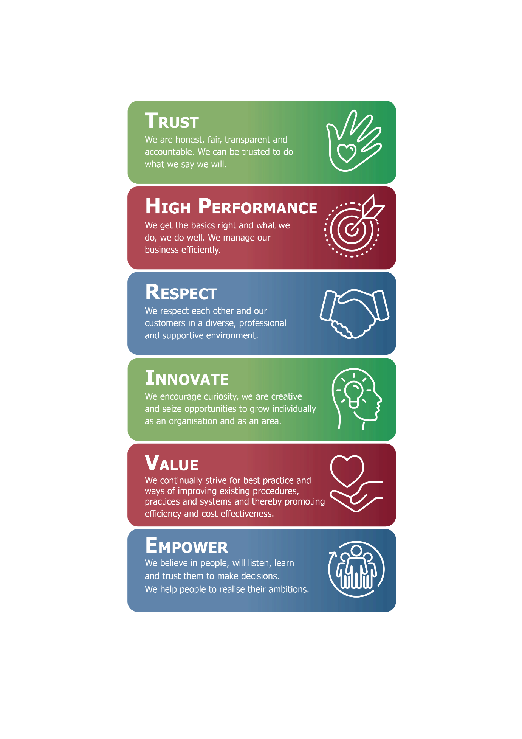
Person Specification:

The requirements for the role are outlined below and will be part of the selection process.
Each of the criteria listed below will be measured by the application form (A), a test / exercise (T), an interview (I), a presentation (P) or documentation (D)
Minimum levels of qualification, knowledge, skills and experience required for this job
Identify | Describe | Essential/  Desirable | Measured by
Qualifications | Educated to at least GCSE (level 1) with English and Maths at grade C or above (or equivalent) | Essential | D
Knowledge | Knowledge of GDPR and data protection requirements | Essential | A/I
 | Good overall IT skills, with knowledge of Microsoft packages (Word and Excel) | Essential | A/T
 | Experience and knowledge of ERP Systems | Essential | A/I
 | Knowledge of Agresso ERP | Desirable | A/I
Skills and experience | Experience in a high-volume administration role/setting | Essential | A/I
 | Able to manage own workload and balance conflicting priorities to meet service requirements and strict deadlines | Essential | A/I
 | Proven Customer Service background | Essential | A/I
 | Experience of working HR transactional/employee life cycle or Establishment Control role | Desirable | A/I
 | Experience of creating system user guides and training documentation for new systems and processes. | Desirable | A/I
 | Able to communicate effectively both verbally and in writing in order to achieve desired outcomes and be able to influence and negotiate when advising and supporting customers/users | Essential | I

- Within the flexible / agile working model there are four clearly defined worker types. Your worker type is determined by your job role.
- Your line manager will inform you which worker type your job role falls under. This is something you will continue to discuss with your line manager as we embed this culture across our organisation.

