# Business Support Officer

|  |  |
| --- | --- |
| **Salary:** | £25,119 - £25,545 |
| **Pay Band:** | NNCBAND02 |
| **Working Hours:** | 37 hours per week |
| **Service Area:** | Adult Social Care |
| **Responsible to:** | Senior Business Support Officer |

## Main Purpose

To work within a comprehensive range of systems to provide a responsive service to customers and ensure the provision of timely and accurate information to relevant team members in support of the Adult Social Care team’s process.

## Role Responsibilities

* Maintain an accurate database with information provided by the accountable workers on relevant customers of Adult Social Care.
* To maintain and support any systems that are in place, including IT, filing and electronic storage systems, that may be in use to ensure effective delivery of services.
* Respond to all correspondence and telephonic enquires related to the team including prioritising and taking necessary administrative actions.
* Provide an efficient and confidential administrative service, including use of all electronic applications including Word, Excel, PowerPoint, databases, Outlook etc, to enable the team to deliver services efficiently.
* Support the assessment and review of customers by ensuring all requested assessments and reviews are received on time.
* Arrange all aspects of inter-agency and inter-departmental meetings as requested including taking minutes of the meetings.
* Processing general financial claims and payments in accordance with NNC regulations and guidelines.
* To maintain a high degree of confidentiality for all information handled.
* To liaise with other staff, both internal and external, to ensure appropriate exchange of information.
* Demonstrate awareness/understanding of equal opportunities and other people’s behavioural, physical, social and welfare needs.
* Ensure that reasonable care is taken at all times for the health, safety and welfare of yourself and other persons, and to comply with the policies and procedures relating to health and safety within the department.

*Carry out any other duties which fall within the broad spirit, scope and purpose of this job description and which are commensurate with the grade of the post.*

### **Safeguarding Commitment**

We are committed to safeguarding and promoting the welfare of children and young people/vulnerable adults. We require you to understand and demonstrate this commitment.

## Person Specification – Business Support Officer

| **ATTRIBUTES** | **ESSENTIAL CRITERIA** | **DESIRABLE CRITERIA** |
| --- | --- | --- |
| **Education and Qualifications** | Good level of general education to GCSE standard. | NVQ Level 3 or equivalent experience. |
| **Experience and Knowledge** | Experience of using IT systems including Word and databases. | Experience of working in a busy office environment. |
| **Ability and Skills** | Accuracy and attention to detail.  Demonstrate good written and verbal communication skills including telephone skills.  Demonstrate good organisational ability.  Able to work independently and as an effective team member with minimum supervision.  A reasonable level of information technology skills, including Word and email.  Able to prioritise own workload and cope well under pressure to meet deadlines.  Ability to build and maintain good working relationships with colleagues and customers to deliver the service. |  |

### Equal Opportunities

Ability to demonstrate awareness/understanding of equal opportunities and other people’s behaviour, physical, social and welfare needs.

### Safeguarding

Demonstrate an understanding of the safe working practices that apply to this role.

Ability to work in a way that promotes the safety and well-being of children and young people/vulnerable adults.

### Health & Safety

Ensure that reasonable care is taken at all times for the health, safety and welfare of yourself and other persons, and to comply with the policies and procedures relating to health and safety within the department.

### Disclosure Level

|  |
| --- |
| **What disclosure level is required for this post?** |
| None  Standard  Enhanced  Enhanced with barred list checks |

## Our Values and Behaviours

Our values define who we are and how we operate, by forming the foundation for how we interact with our customers, colleagues and provide our services. They are also at the forefront of our decision making and delivery and include:

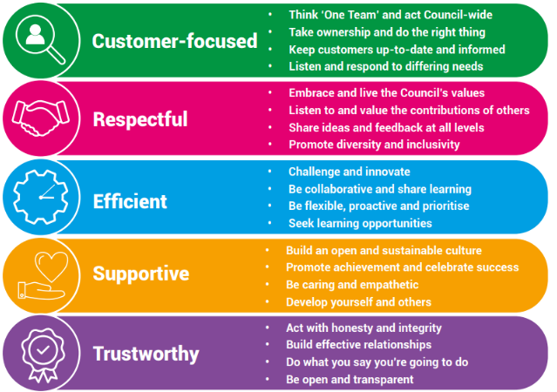

**Our Key Commitments**

Our key commitments help ensure that the priorities we make, now and in the future, maintain the necessary breadth of focus in those areas that we believe matter most.

Our key commitments are:

* **Active, fulfilled lives:** We will help people live healthier, more active, independent and fulfilled lives.
* **Better, brighter futures:** We will care for our young people, providing them with a high-quality education and opportunities to help them flourish.
* **Safe and thriving places:** We will enable a thriving and successful economy that shapes great places to live, learn, work and visit.
* **Green, sustainable environment:** We will take a lead on improving the green environment, making the area more sustainable for generations to come.
* **Connected communities:** We will ensure our communities are connected with one another, so they are able to shape their lives and the areas where they live.
* **Modern public services:** We will provide efficient, effective and affordable services that make a real difference to all our local communities.

## Why choose us?

We offer a fantastic working environment including diverse and active staff networks, great flexible working opportunities and well as many other benefits, you will:

* Receive a generous annual leave allowance.
* Have access to our Employee Assistance Programme which offers a confidential service for employees and their families 24 hours a day / 7 days a week. The programme provides expert advice and counselling in areas such as finances, family and personal problems, work issues, health related problems, childcare and consumer rights.
* Join the Local Government Pension Scheme (LGPS), which is a tax approved occupational pension scheme with a generous employer contribution rate, immediate life cover and ill-health protection. Benefits are based on the length of your membership and final salary.

We are proud to be a recognised Disability Confident Employer and is committed to providing an inclusive recruitment process and will offer an interview to disabled applicants who meet the essential criteria for the role.

