# Community Support Worker

|  |  |
| --- | --- |
| **Salary:** | £30,559 - £31,586 |
| **Pay Band:** | NNCBAND04 |
| **Working Hours:** | 37 hours per week |
| **Service Area:** | Adult Social Care |
| **Responsible to:** | Principal Social Worker/Principal Care Manager |

## Main Purpose

Assist with the provision of positive intervention and support for adults with mental health problems; physical and/or learning disabilities.

Promote independence and community living and help minimise the risk of hospitalisation or admission to residential care.

## Role Responsibilities

* Assist on a managed basis, as part of the team, with a monitored caseload of short term and/or less complex cases, which require visiting, monitoring and provision of support to customers to ensure ongoing services.
* With reference to the individual’s care plan provide practical and emotional support to customers to help them maintain independent living. In appropriate cases: Assist customers with physical disabilities to carry out activities, hygiene routines and manage medication as directed within their care plans to help maintain health and wellbeing.
* With reference to the individual’s care plan promote independence through the provision of information to customers and through liaison with carers, internal and external agencies to help customers to access and utilise resources in the local community and maintain financial independence.
* Act as a key worker for designated customers and in consultation with other stakeholders to ensure that customers are supported in accessing and applying for the services and benefits, they are entitled to from the relevant agencies and authorities.
* Assist senior officers/case managers with ongoing assessment and provide information to help amend and update care plans so that changes in customers’ assessed needs and circumstances are recorded and addressed appropriately
* Ensure that all administrative tasks relating to the job are carried out in an effective and timely manner for accurate audit and record keeping and accordingly to contribute to reviews.
* Demonstrate awareness/understanding of equal opportunities and other people’s behavioural, physical, social and welfare needs.
* Ensure that reasonable care is taken at all times for the health, safety and welfare of yourself and other persons, and comply with the policies and procedures relating to health and safety within the company

*Carry out any other duties which fall within the broad spirit, scope and purpose of this job description and which are commensurate with the grade of the post.*

### **Safeguarding Commitment**

We are committed to safeguarding and promoting the welfare of children and young people/vulnerable adults. We require you to understand and demonstrate this commitment.

## Person Specification - Community Support Worker

### Qualifications

* NVQ Level 2 in Care or equivalent experience.
* GCSE or equivalent in English and Maths.

### Background and Experience

* Knowledge of the issues affecting residents within North Northamptonshire.
* Proven experience of health or care work.
* Experience of delivering care services in a community based setting.

### Ability & Skills

* Good verbal and written communication skills sufficient to write clear, concise and accurate reports and to enable effective communication with a number of different agencies.
* Excellent interpersonal skills with the ability to listen and interact effectively with and on behalf of customers and to react appropriately to a crisis situation.
* Practical approach to resolving problems and achieving results.

### Equal Opportunities

Ability to demonstrate awareness/understanding of equal opportunities and other people’s behaviour, physical, social and welfare needs.

### Safeguarding

Demonstrate an understanding of the safe working practices that apply to this role.

Ability to work in a way that promotes the safety and well-being of children and young people/vulnerable adults.

### Health & Safety

Ensure that reasonable care is taken at all times for the health, safety and welfare of yourself and other persons, and to comply with the policies and procedures relating to health and safety within the department.

### Disclosure Level

|  |
| --- |
| **What disclosure level is required for this post?** |
| None  Standard  Enhanced  Enhanced with barred list checks |

## Our Values and Behaviours

Our values define who we are and how we operate, by forming the foundation for how we interact with our customers, colleagues and provide our services. They are also at the forefront of our decision making and delivery and include:

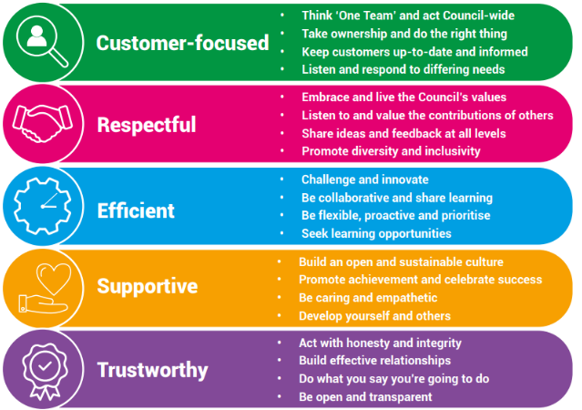

**Our Key Commitments**

Our key commitments help ensure that the priorities we make, now and in the future, maintain the necessary breadth of focus in those areas that we believe matter most.

Our key commitments are:

* **Active, fulfilled lives:** We will help people live healthier, more active, independent and fulfilled lives.
* **Better, brighter futures:** We will care for our young people, providing them with a high-quality education and opportunities to help them flourish.
* **Safe and thriving places:** We will enable a thriving and successful economy that shapes great places to live, learn, work and visit.
* **Green, sustainable environment:** We will take a lead on improving the green environment, making the area more sustainable for generations to come.
* **Connected communities:** We will ensure our communities are connected with one another, so they are able to shape their lives and the areas where they live.
* **Modern public services:** We will provide efficient, effective and affordable services that make a real difference to all our local communities.

## Why choose us?

We offer a fantastic working environment including diverse and active staff networks, great flexible working opportunities and well as many other benefits, you will:

* Receive a generous annual leave allowance.
* Have access to our Employee Assistance Programme which offers a confidential service for employees and their families 24 hours a day / 7 days a week. The programme provides expert advice and counselling in areas such as finances, family and personal problems, work issues, health related problems, childcare and consumer rights.
* Join the Local Government Pension Scheme (LGPS), which is a tax approved occupational pension scheme with a generous employer contribution rate, immediate life cover and ill-health protection. Benefits are based on the length of your membership and final salary.

We are proud to be a recognised Disability Confident Employer and is committed to providing an inclusive recruitment process and will offer an interview to disabled applicants who meet the essential criteria for the role.

