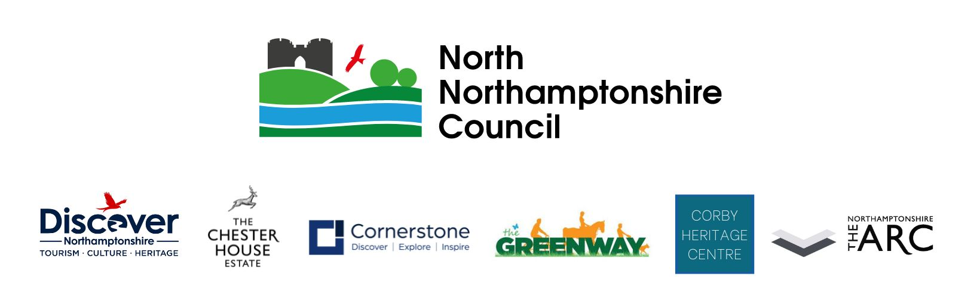

**Job description**

|  |  |
| --- | --- |
| **Details of the job** | |
| Post title: | Venue and Operations Manager |
| Salary grade: |  |
| Hours: | Full Time, 37 hrs per week |
| Location: | Chester House Estate, Wellingborough |
| Reports to: | Chester House Estate General Manager |
| Service area: | Chester House Estate – North Northamptonshire Council |

In September 2022, North Northamptonshire Council developed a new service ‘Culture, Tourism and Heritage’. This new service has brought together departments across the council including Tourism delivery, theatres, events and heritage assets which now all sit within the Communities and Wellbeing Directorate.

North Northamptonshire Council has the vision:

***‘To create a new sustainable, efficient, and engaging heritage, cultural and tourism service that will shine a light on the outstanding assets we have within North Northamptonshire, whilst protecting and preserving heritage for future generations. Working with partners, we aim to improve and increase the tourism economy by developing infrastructure and introducing pioneering marketing strategies to attract inward investment and visitors.’***

The Culture, Tourism and Heritage Service includes the following areas:

* The Chester House Estate (CHE)
* Corby Heritage Centre
* Cornerstone
* Northamptonshire Archaeological Resource Centre (ARC)
* North Northamptonshire Council Events
* Discover North Northamptonshire Hub
* Destination Nene Valley (DNV)
* The Greenway Project
* Theatre Contracts for the Corby Core Theatre, The Lighthouse Theatre and The Castle Theatre.
* Visitor Attraction / Park contracts for Stanwick Lakes, Twywell Hill and Dales
* Cultural, Heritage and Tourism Partnerships including with Made with Many, Love Corby, The Northamptonshire Heritage Forum, Northamptonshire Surprise, Rockingham Forest Trust and The Nene Rivers Trust.

The Chester House Estate is a £14.5m restoration project funded by North Northamptonshire Council and The National Lottery Heritage Fund. Since opening in 2021, the site has become a popular visitor attraction, educational facility and archaeological archiving centre. Our educational programmes focus on farming, sustainability, history, geography, archaeology and farm business diversification.

We wish to make the Chester House Estate somewhere that people want to come; a place that through education, learning and enjoyment adds value to their lives, and helps them to appreciate Northamptonshire's outstanding heritage. We will deliver a quality, unique and sustainable educational offering. We will champion accessible education for all ages and communities, our mission is to give the opportunity to engage with the Chester House Estate’s past, present and future.

We have plans to take our visitor engagement, functions and events to a whole new level and we need someone fantastic to be part of our team to lead on this delivery. The Venue and Operations Lead will be a key member of the Chester House Leadership Team, acting as Deputy when required for the General Manager. The Venue and Operations role leads and line-manages the visitor services team including the public events, weddings and conferencing departments. The Venue and Operations Lead will also play a key role in the development of new business ventures and will develop current business operations such as weddings, parties and functions to ensure maximum revenue for the site.

The Venue and Operations Manager will act as Day Manager on a rota basis. Due to the nature of the business, regular weekend and Bank Holiday working is required. The Manager is also a key member of the Chester House Estate Leadership Team and will need to work together with other managers to ensure our visitors have a safe and fun day at The Chester House Estate.

Occasionally situations may arise that require the post holder to perform other duties or tasks as may be reasonably requested by the estate. In addition, all employees are expected to adhere to the organisations commitment to providing a safe and positive working environment for all.

This role includes work on a 5/7-day roster, which will include regular weekends and bank holidays.

**Overall purpose of the post**

1. To lead and line manage the visitor services team including the weddings, events and conferencing departments. (Team of 3 Venue Officers and 1 Events Officer)
2. To play a key role in the development of new business ventures and will develop current business operations such as weddings, parties and conferencing functions to ensure maximum revenue for the site.
3. To develop new public events to increase ticketed income, secondary income and footfall.
4. To be a key member of the Chester House Leadership Team, acting as Deputy when required for the Chester House Estate Business Manager.
5. Responsible for delegated operational budgets (income generation as well as expenditure control).

**Main accountabilities**

1. Create great visitor experiences by organising and delivering visitor and business engagement activities to bring the estate hireable facilities to life in new and innovative ways.
2. Develop and lead weddings, function hires and conferencing events, and the bed and breakfast offer, through a culture of excellent customer care and ensuring all visitor areas are presented to agreed high standards.
3. Monitor the Visitor Survey and provide clear feedback and recommendations to the Chester House Estate General Manager.
4. Work with other managers to ensure the effective delivery of education activities.
5. Manage financial performance. Manage, develop, monitor and evaluate the commercial aspects of visitor services including the weddings, function hire and conferencing bookings sales. Contribute to setting and be responsible for achieving stretching financial targets, maximising sales and income generation on site. Monitor and control resources delegated to you (including casual/seasonal wage budgets) and comply with agreed financial procedures.
6. Take the lead with the internal financial payments ensuring all generated income is accounted for accurately and timely.
7. Develop the business byidentifying new opportunities to drive income and innovation, harnessing ideas from your team and customer feedback. Contribute to and deliver the property business plan. Support colleagues to develop their business areas, offering hands-on, practical help when needed and support the General Manager with creating successful fundraising bids.
8. Provide clear leadership and direction to staff and volunteers, maintaining effective communication and ensuring they are adequately supervised. Develop rotas that provide suitable staffing cover whilst remaining within agreed monthly wage budget. Work closely with other teams in the delivery of the property business plan and other projects.
9. Deal with visitor enquiries, correspondence and complaints as necessary, in a timely and positive manner to maintain/restore goodwill. To work with the marketing / social media lead and PR consultancy for the estate events and advertisement. Taking existing guidelines and website architecture into account, you will work to deliver year-round content strategies, tone of voice and drive the amplification and impact of our work.
10. Utilise Daily Duty Manager inspections ensuring full site security during opening and closing of the site.
11. Observe all Health & Safety and statutory regulations including site specific checklists.

This job description reflects the major tasks to be carried out by the post holder and identifies a level of responsibility at which they will be required to work. In the interests of effective working, the major tasks may be reviewed from time to time to reflect changing needs and circumstances. Such reviews and any consequential changes will be carried out in consultation with the post holder.

PERSON SPECIFICATION

|  |  |
| --- | --- |
| Post Title: | Venue and Operations Manager |
| Grade |  |
| Service Area: | Culture, Tourism and Heritage |

|  |  |  |
| --- | --- | --- |
| **ATTRIBUTES** | **ESSENTIAL CRITERIA** | **DESIRABLE CRITERIA** |
| **Education and Qualifications** | Graduate qualification (or equivalent experience) in Management, Business Studies, Marketing, Communications, Finance or related discipline. | Personal License holder.  First aid trained  Level 3 food hygiene certificate |
| **Experience and Knowledge** | Significant and proven experience of retail, business, marketing and/or visitor services, especially within the charity sector  Experience managing teams from varied backgrounds.  Demonstrated ability to grow a commercial operation. | Experience of working with volunteers or community groups  Appreciation and understanding of the importance of the historic environment. |

|  |  |  |
| --- | --- | --- |
| **ATTRIBUTES** | **ESSENTIAL CRITERIA** | **DESIRABLE CRITERIA** |
| **Ability and Skills** | Excellent customer service skills and high service standards.  Strong relationship management and influencing skills  Excellent planning and report writing skills  Excellent time-management skills  Confident, flexible and relaxed management style, able to communicate effectively with everyone.  IT skills to manage a large EPOS and online book system. | A dynamic leadership style, and the ability to manage a diverse permanent and seasonal team.  Monitoring, evaluation and analytical skills |
| **Equal Opportunities** | Ability to demonstrate awareness/understanding of equal opportunities and other people’s behaviour, physical, social and welfare needs. |  |