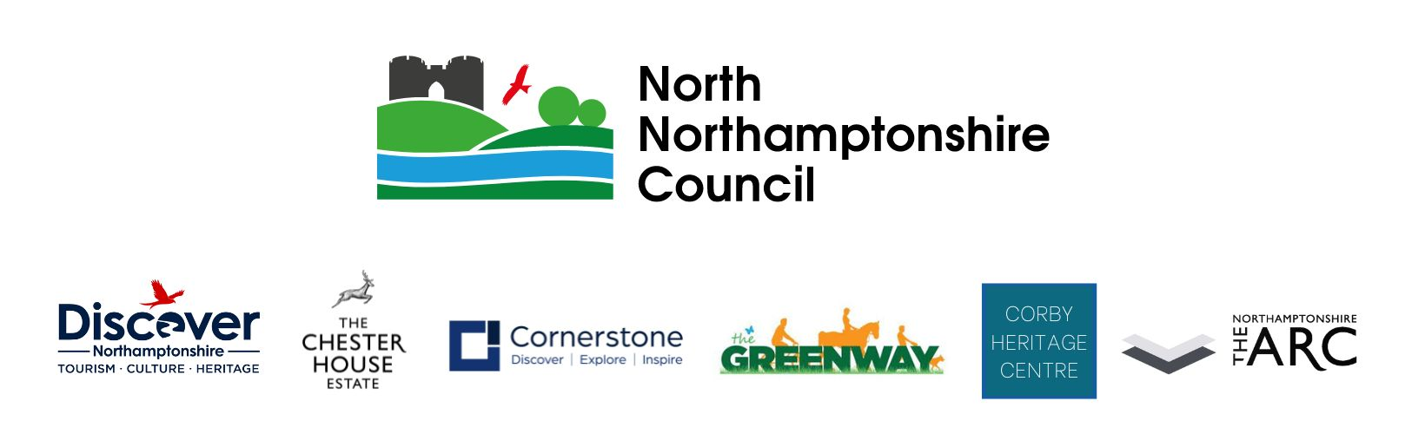

**Job description**

|  |  |
| --- | --- |
| **Details of the job** | |
| Post title: | Marketing Officer |
| Salary grade: |  |
| Hours: | Full Time, 37 Hours per week |
| Location: | Chester House Estate, Wellingborough |
| Reports to: | Head of Culture, Tourism and Heritage |
| Service area: | Culture, Tourism and Heritage |

**Overall purpose of the post**

The Marketing Officer will lead on the delivery of dynamic and effective marketing and communications activity to raise the profile, drive engagement and grow audiences across The Chester House Estate, Corby Heritage Centre, Discover Northamptonshire, Cornerstone, The Greenway project and our NN Events. This role is instrumental in developing and implementing integrated campaigns that span digital, print, PR, social media, events and stakeholder engagement, helping position the service as a vibrant, accessible and high-quality.

As a strategic and creative thinker, the post holder will be responsible for planning, producing and evaluating content across all channels, with a particular focus on enhancing the service’s digital footprint. This includes managing and developing websites, social media accounts, email marketing, online ticketing platforms, and e-commerce functionality, ensuring content is engaging, inclusive, accessible and aligned with organisational priorities.

Working closely with internal teams and the wider North Northamptonshire Council (NNC) communications team, the Marketing Officer will act as the primary point of contact for marketing queries, press enquiries, approvals and content requests, ensuring all communications are timely, consistent and on brand.

The role will also involve leading on design and production for on-site and off-site printed collateral (e.g. signage, flyers, event materials), as well as supporting and promoting income-generating initiatives such as ticketed events, venue hire, retail and catering. A strong commercial focus, alongside a deep understanding of audience development and community engagement, will be key to success.

This is a hands-on role, requiring the ability to plan and deliver campaigns while also responding quickly to opportunities and challenges. The Marketing Officer must be confident working independently, managing multiple projects and deadlines and contributing to strategic marketing planning.

The role operates on a 5-in-7-day working pattern, including regular weekends and bank holidays, to support the live delivery of events and promotional activity. The post holder will also be expected to contribute to a safe, inclusive, and positive working environment and may be asked to carry out other reasonable duties as required by the estate.

**Main accountabilities**

* Lead on the development, maintenance, and regular updates of key service websites, including The Chester House, Cornerstone and Discover Northamptonshire.
* Act as the primary liaison for the external PR consultant, coordinating the provision of accurate information, imagery and approvals from the internal NNC Communications team.
* Manage all social media platforms, delivering engaging day-to-day content, announcements, campaigns and event promotion to grow online presence and audience reach.
* Design and deliver print advertising materials, including leaflets, posters, banners and on-site signage, ensuring consistency with brand guidelines.
* Arrange and oversee professional photography and video production across all destinations for promotional and archival use.
* Support the growth of the Culture, Tourism and Heritage brand by developing campaigns that target and attract new and diverse audiences.
* Represent the service at relevant EXPOs, leisure and heritage shows and networking events to build awareness and promote offerings to external stakeholders.
* Monitor and supervise small expenditure budgets, ensuring responsible and efficient use of resources.
* Produce audience insight, data analysis and sales reports to inform decision-making and support departmental leads.
* Oversee the smooth operation of ticketing and booking systems for events, services and site access across all destinations.
* Provide ad hoc administrative support to the Head of Service and Department Managers, contributing to the smooth day-to-day running of the wider team.
* Ensure all data collection, storage, and handling complies with GDPR and organisational data protection policies.

This job description reflects the major tasks to be carried out by the post holder and identifies a level of responsibility at which they will be required to work. In the interests of effective working, the major tasks may be reviewed from time to time to reflect changing needs and circumstances. Such reviews and any consequential.

PERSON SPECIFICATION

|  |  |
| --- | --- |
| Post Title: | Marketing Officer |
| Grade |  |
| Service Area: | Culture, Tourism and Heritage |

|  |  |  |
| --- | --- | --- |
| ATTRIBUTES | ESSENTIAL CRITERIA | DESIRABLE CRITERIA |
| Education and Qualifications | 3 GCSE Qualifications (minimum of C grade for English and Maths). | First aid trained |
| Experience and Knowledge | Excellent communications and interpersonal skills to be able to effectively engage with a range of audiences and stakeholders at strategic, operational levels, including elected members and members of the public.  Excellent influencing and advocacy skills. The ability to positively influence and instil confidence in team members, senior officers and stakeholders  Experience with using WordPress  Experience with Facebook, Twitter, Instagram, Tic-Tok, LinkedIn.  Experience with using Canva or a similar design tool. | Experience of working with volunteers or community groups  Appreciation and understanding of the importance of the historic environment. |

|  |  |  |
| --- | --- | --- |
| ATTRIBUTES | ESSENTIAL CRITERIA | DESIRABLE CRITERIA |
| Ability and Skills | Excellent customer service skills and high service standards.  Strong relationship management and influencing skills  Excellent planning and report writing skills  Excellent time-management skills  Confident, flexible and relaxed style, able to communicate effectively with everyone.  IT skills to manage a large EPOS and online book system. | Monitoring, evaluation and analytical skills |
| Equal Opportunities | Ability to demonstrate awareness/understanding of equal opportunities and other people’s behaviour, physical, social and welfare needs. |  |