Description and Person Specification
Local Area Partnership Project Lead
(salary band)

Purpose & Impact:
Hosted by Public Health in West Northamptonshire Council the role deals with delivering a broad ranging programme of work to support the implementation and sustainability of our Local Area Partnerships (LAP). It will require the post holder to manage a wide range of relationships and work closely with multiple stakeholders including colleagues from the VCSE, Health, Adult Social Care, Childrens Services, Police, Fire & Safety, Public Health, GPs, Town & Parish Councils and our Elected Members. The postholder will undertake the following activities:
- Ensure governance of the LAP is robust and all members understand their responsibilities and escalation route.
- Based on insights intelligence lead on the development of a comprehensive LAP Delivery Plan to include activities and outcomes and ensure they are mapped to the LYBL ambitions.
- Work with internal and external colleagues to develop the LAP Communications Plan including website, LAP Engagement Plan and LAP scorecard.
- Lead on the development of all pilots/projects as agreed by the LAP membership and work with stakeholders to agree solutions.
- Ensure all priorities identified as needing a Multi Agency Team approach align with and delivers on the LYBL ambitions. Ensure the Monitoring Framework captures plans, actions and outcomes led by the Multi Agency Teams. Identify the appropriate partners to join the Multi Agency Teams and provide advice and guidance to them where necessary.
- Identify issues and challenges raised by the LAP for escalation to the Health and Wellbeing Forum. Ensure the LAP identifies and sends representation to the Health and Wellbeing Forum. Ensure the representative is supported with appropriate paperwork when attending the Forum meeting. Facilitate feedback from the Forum to the LAP.
- Provide administration support for the LAP meetings if necessary.
- Work in partnership with colleagues in WNC to identify where (wider determinants of health) services are best delivered at LAP level and assist with re-design.
- Provide support to communities in the LAP to access funding through the Targeted Intervention Fund (when available).
- Work in collaboration with other LAP Project Leads to share learning and best practice (Learning Set approach).

Accountable to:

This role is accountable to the Assistant Director for Place Development. The role sits in Public Health within People Services Directorate in West Northamptonshire Council.

Responsibilities:

 | Main accountabilities
 | Project management. To understand and interpret business requirements, undertaking all planning and coordination of the project. Required to recommend appropriate solutions and is ultimately accountable for delivering solutions that meets the needs of the local partnership.
 | Stakeholder management. Responsible for ensuring all stakeholders and their degree of interest in a project/project outcome are identified. The postholder is required to develop effective relationships with stakeholders, ensuring expectations and project deliverables are met.
 | Project governance. To work within the relevant policies, procedures, frameworks and standard operating procedures ensuring all projects are managed consistently across the organisation and are clearly defined.
 | Resources. To work within an allocated budget, responsible for the monitoring and reporting of all project spend. Responsible for ensuring the budget does not exceed constraints as set out by the Senior Responsible Owner (SRO). The postholder is expected to forecast spend and identify potential issues or risks related to resources through the life of a project.
 | Leadership. Responsible for overseeing the completion of all tasks related to projects being managed. The postholder is expected to identify what resources are needed and at what stage of the project. Responsible for defining the work programme and setting priorities for others.
 | Service Improvement. As part of the role the postholder is expected to manage business transformation and develop capability to embed service improvement tools designed to support the Council’s corporate outcomes and LYBL ambitions.
 | Project documentation. To ensure all aspects of the project are appropriately recorded. This includes the work programme, risks, benefits and cost, ensuring the project is delivered within the required timescales and within any set constraints (i.e. cost/required savings).
 | Advice and reporting. To report to the necessary stakeholders providing advice on required solutions to issues that have arisen during a project. To report accurate, up to date information to the SRO and relevant parties as and when required.
9. | Communication. To communicate effectively with all stakeholders and the project team ensuring solutions are delivered to the highest quality. Required to communicate in a number of methods and responsible for determining the most appropriate method of communication; i.e. face to face, written etc.

This job description reflects the major tasks to be carried out by the post holder and identifies a level of responsibility at which they will be required to work. In the interests of effective working, the major tasks may be reviewed from time to time to reflect changing needs and circumstances. Such reviews and any consequential changes will be carried out in consultation with the post holder.

Our Values& Behaviours
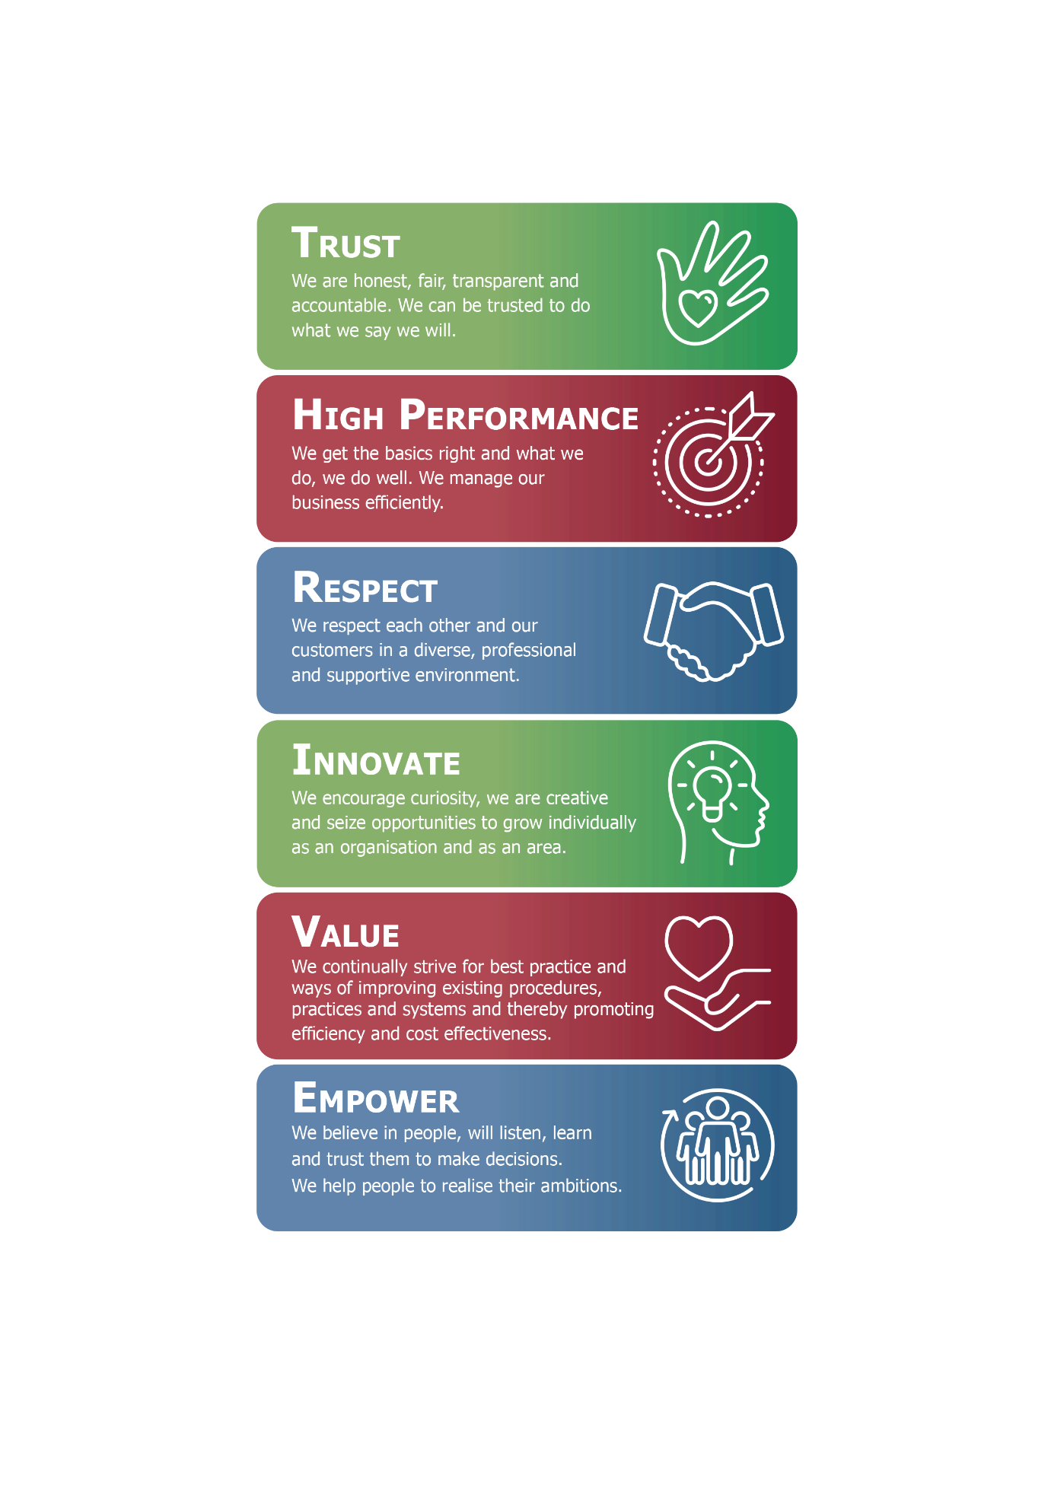
Person Specification:

The requirements for the role are outlined below and will be part of the selection process.
Person Specification
Qualifications, knowledge, skills and experience

Minimum level of qualifications required for this job
Qualifications Required | Subject | Essential/  Desirable
Degree in a related area, e.g. business studies or equivalent professional qualification or equivalent by experience. |  | E
Recognised project management qualification | e.g. PRINCE2, MSP, Agile, LEAN | D
Minimum levels of knowledge, skills and experience required for this job
Identify | Describe | Essential/  Desirable
Knowledge
Project and change management concepts | - Knowledge of project/change management concepts and methodologies e.g. PRINCE2. | E
Business analysis | Knowledge of business process mapping and analysis tools e.g. Visio | E
Local government context | - Awareness of the National and Local Government agenda, current issues and challenges. | D
Health services context | - Awareness of the National and Local NHS agendas, current issues and challenges | D
Skills
Organisational skills | Ability to plan and deliver to set timescales, as well as prioritising as appropriate. | E
Interpersonal skills | Ability to influence and negotiate with potential providers of solutions, including interpreting end user requirements and make recommendations to the project SRO. | E
Change management | Ability to develop and deliver projects and successfully manage change in working practices as a result of a project. | E
Political awareness | - Ability to recognise political sensitivity within a project. | E
Experience | Give an idea of the type and level of experience required do not specify years of experience.
Project management | Experience of managing small to medium sized projects (< £250k) | E
Project management tools & techniques | Experience of using tools and techniques associated with service improvement and project management. | E
Change management | Experience of managing small scale business improvement or change, e.g. for a single team. | E
Business process analysis | - Experience of managing business improvements, including full process mapping and options analysis and appraisal. | E
Systems/data analysis | Experience of analysing and solving complex process and systems problems | D
Leadership skills | Demonstrable experience of leading people and teams | E
Stakeholder management | Experience of identifying, managing and influencing stakeholders throughout all phases of a project. | D

- Within the flexible / agile working model there are four clearly defined worker types. Your worker type is determined by your job role.
- Your line manager will inform you which worker type your job role falls under. This is something you will continue to discuss with your line manager as we embed this culture across our organisation.

