Job Description and Person Specification
Head of Legal (People)
Head of Legal (Place)
Head of Legal (Corporate)

Purpose & Impact:

- To provide legal advice and assistance to the Council.
- To deputise for the Deputy Director Law and Governance as required.
- To manage the designated legal team including training, budgets and workload.
- To work collaboratively with all members of the Law and Governance Service to deliver excellent quality services across the full range of functions provided by the Service.
Accountable to:

This post is accountable to the Deputy Director Law and Governance.

The post sits within Law and Governance, part of the Corporate Services Directorate in West Northamptonshire Council. The post is responsible for all employees within the designated legal team.

Responsibilities:

- To carry out complex legal work and act as the Council’s principal legal adviser in respect of the work areas of the designated legal team.
- To play a key role in the management and review of legal strategies in relation to high risk and complex legal cases.
- Establishing and maintaining effective working relationships with elected councillors, internal and external partners and stakeholders.
- Promoting a positive image of the Council.
- Leading, managing and inspiring members of the designated legal team.
- Providing legal advice to the Council, the Cabinet, committees, sub committees, panels and working groups; including the obtaining of external legal advice and opinion, where appropriate.
- To support and deputise for the Deputy Director in delivering excellence across the Legal Service through the development of high performance, effective delegation, communication, corporate working and prioritising customer service and satisfaction.
- To identify and summarise developments in areas of practice and cascade these developments to legal team members and other service areas across the Council / elected Members to include the delivery of training on areas of practice.
- To ensure the service provided by the designated legal team is responsive to the needs of the Council and reflects the core values and aims of the Council including actively participating in the development of the Law and Governance Service and proposing and monitoring performance against Key Performance Indicators.
- To actively explore income generation opportunities and exploit opportunities for the digitalisation of legal services, actively engaging and supporting the transformation agenda across the Council.
- To actively support service areas in the preparation of reports and policies to ensure that they reflect key legislation, best practice, risks and governance processes.
- Leading by example in modelling the conduct, behaviour and values expected of the Council’s employees and establish a working environment within the designated legal team in which individuals can excel.
- Actively challenge and seek to eliminate any directly or indirectly discriminatory practice or behaviours.
- Demonstrate awareness/understanding of other people’s behavioural, physical, social and welfare needs. Ensure that reasonable care is taken at all times for the health, safety and welfare of yourself and other persons, to certify compliance with policies and procedures relating to health and safety within the service.

This job description reflects the major tasks to be carried out by the post holder and identifies a level of responsibility at which they will be required to work. In the interests of effective working, the major tasks may be reviewed from time to time to reflect changing needs and circumstances. Such reviews and any consequential changes will be carried out in consultation with the post holder.

Our Values& Behaviours
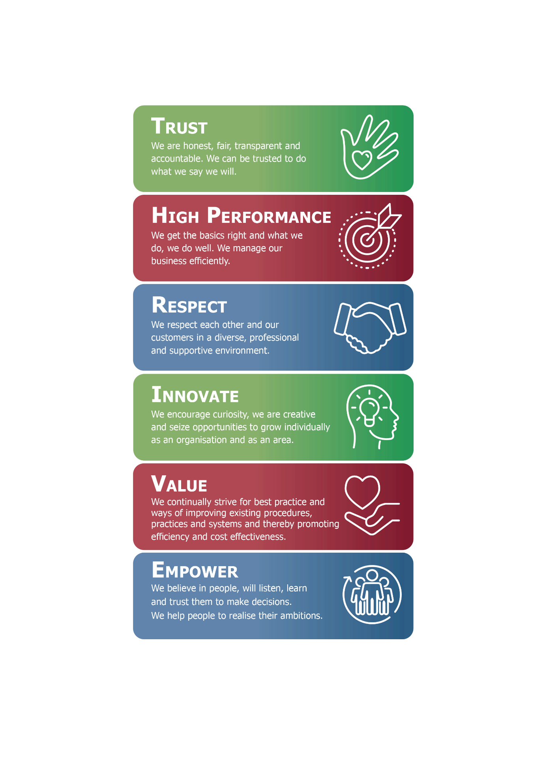
Person Specification:

The requirements for the role are outlined below and will be part of the selection process.
Each of the criteria listed below will be measured by the application form (A), a test / exercise (T), an interview (I), a presentation (P) or documentation (D)
Minimum levels of qualification, knowledge, skills and experience required for this job
Identify | Describe | Essential/  Desirable | Measured by
Qualifications
Legal Qualification | Solicitor of the Supreme Court of England and Wales or Fellow of the Chartered Institute of Legal Executives or comparable alternative. | Essential | A and D
Management qualification | Institute of Leadership and Management Qualification or comparable alternative / experience. | Desirable | A and D
Knowledge
Local Authority | Knowledge of the legislation governing the operation of Local Authorities | Essential | A T/P and I
Designated legal team knowledge | Knowledge of the legislation governing the service specific areas of the designated legal team | Essential | A T/P and I
Leadership and Management | Experience of leading and managing professional teams and managing change. | Essential | A and I
Skills and experience
Relationship Skills | Ability to build effective working relationships with a diverse range of stakeholders. | Essential | A and I
Communication and influencing skills | Excellent communication skills both verbal and written including the ability to shape and influence successful outcomes. | Essential | A and I
Leadership Skills | Ability to lead a team to deliver high levels of performance, setting clear priorities and a strong approach to performance management. | Essential | A and I
Interpret and apply legislation | Ability to interpret complex legislation and explain it to a variety of audiences providing strategic legal advice and support within a complex and changing organisation | Essential | A and I
Commercial Focus Experience | Experience of leading a commercially focussed team. | Essential | A and I
Management Experience | Experience of providing complex advice in a middle management capacity | Essential | A and I
Management Experience | Experience in the supervision, development and management of people, finances and other resources to achieve service objectives | Essential | A and I

- Within the flexible / agile working model there are four clearly defined worker types. Your worker type is determined by your job role.
- Your line manager will inform you which worker type your job role falls under. This is something you will continue to discuss with your line manager as we embed this culture across our organisation.

