Job Description and Person Specification
Principal Lawyer (People)
Principal Lawyer (Place)
Principal Lawyer (Corporate)

Purpose & Impact:

- To assist in the delivery of a Legal Service providing legal advice and assistance to the Council.
- To deputise for the relevant Head of Legal as required.
- To assist in the management of the designated legal team.
- To work collaboratively with all members of the Law and Governance Service to deliver excellent quality services across the full range of functions provided by the legal service.
Accountable to:

This post is accountable to the relevant Head of Legal.

The post sits within Law and Governance, part of the Corporate Services Directorate in West Northamptonshire Council. The post is responsible for all employees within the designated legal team.

Responsibilities:

- To provide specialist legal advice and representation on complex cases within the designated legal team to Senior Officers, their service areas and departments.
- Establishing and maintaining effective working relationships with elected councillors, internal and external partners and stakeholders.
- Promoting a positive image of the Council.
- Assisting the Head of Legal in leading, managing and inspiring members of the designated legal team including providing day to day management of designated team members within the team.
- Providing ad-hoc legal advice to the Council, the Cabinet, committees, sub committees, panels and working groups; including the obtaining of external legal advice and opinion, where appropriate.
- To provide support and deputise for the relevant Head of Legal in undertaking any legal work and in planning, managing and administering the designated legal team activity to ensure effective service delivery.
- To promote, develop and ensure that the Legal Service is delivered to the highest standard, through service improvement and transformation being an agent of change within the designated legal team.
- To identify and summarise developments in areas of practice and cascade these developments to legal team members and other service areas across the Council / elected Members to include the delivery of training on areas of practice.
- To actively promote and champion a commercial approach to the operation of the Legal Service.
- To assist the relevant Head of Legal to actively explore income generation opportunities and exploit opportunities for the digitalisation of legal services.
- To actively support service areas in the preparation of reports and policies to ensure that they reflect key legislation, best practice, risks and governance processes.
- Leading by example in modelling the conduct, behaviour and values expected of the Council’s employees and establish a working environment within the designated legal team in which individuals can excel.
- Actively challenge and seek to eliminate any directly or indirectly discriminatory practice or behaviours.
- Demonstrate awareness/understanding of other people’s behavioural, physical, social and welfare needs. Ensure that reasonable care is taken at all times for the health, safety and welfare of yourself and other persons, to certify compliance with policies and procedures relating to health and safety within the service.

This job description reflects the major tasks to be carried out by the post holder and identifies a level of responsibility at which they will be required to work. In the interests of effective working, the major tasks may be reviewed from time to time to reflect changing needs and circumstances. Such reviews and any consequential changes will be carried out in consultation with the post holder.

Our Values& Behaviours
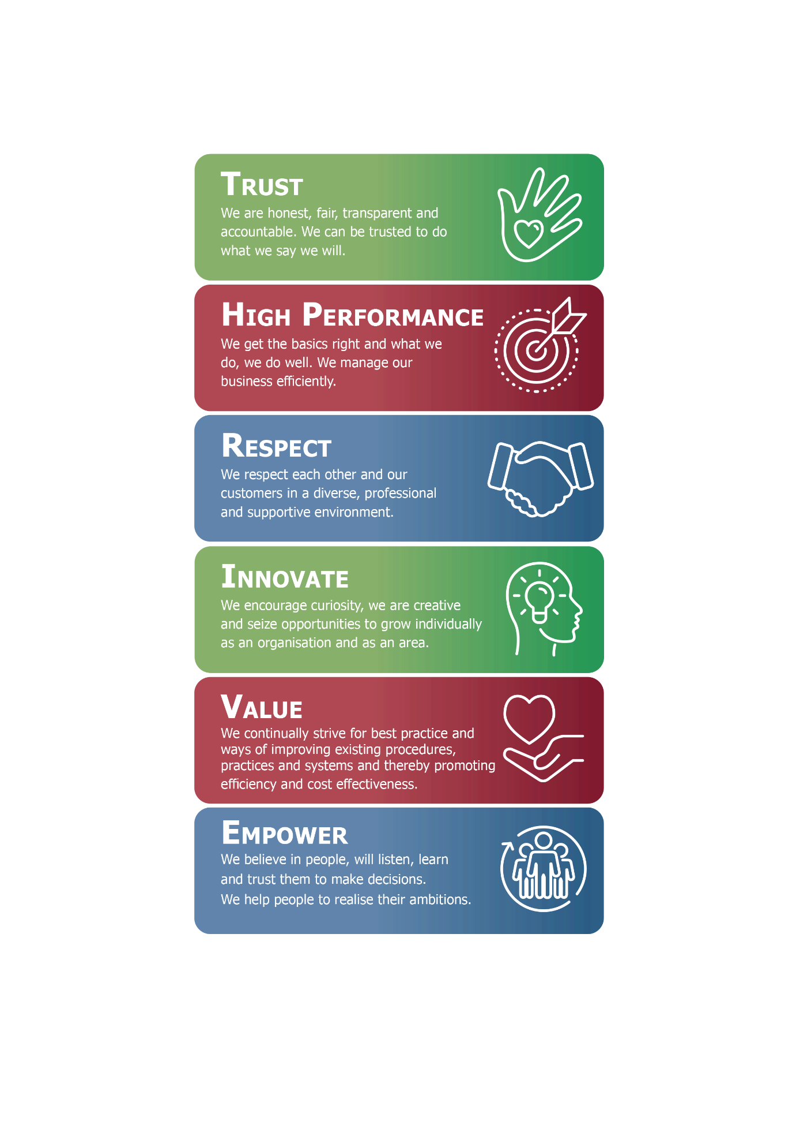
Person Specification:

The requirements for the role are outlined below and will be part of the selection process.
Each of the criteria listed below will be measured by the application form (A), a test / exercise (T), an interview (I), a presentation (P) or documentation (D)
Minimum levels of qualification, knowledge, skills and experience required for this job
Identify | Describe | Essential/  Desirable | Measured by
Qualifications
Legal Qualification | Solicitor of the Supreme Court of England and Wales or Fellow of the Chartered Institute of Legal Executives or comparable alternative. | Essential | A and D
Management qualification | Institute of Leadership and Management Qualification or comparable alternative / experience. | Desirable | A and D
Knowledge
Local Authority | Knowledge of the legislation governing the operation of Local Authorities | Essential | A and I
Designated legal team knowledge | Knowledge of the legislation governing the service specific areas of the designated legal team. | Essential | A and I
Leadership | Knowledge to effectively support the relevant Head of Legal in leading and managing the designated legal team. | Essential | A and I
Skills and experience
Relationship Skills | Ability to build effective working relationships with a diverse range of stakeholders. | Essential | A and I
Communication and influencing skills | Excellent communication skills both verbal and written including the ability to shape and influence successful outcomes. | Essential | A and I
Research Skills | Excellent research skills to effectively and confidently advise on a wide variety of legal issues. | Essential | A and I
Advising Experience | Proven experience as a Lawyer providing post qualification advice. | Essential | A and I
Working flexibly | Experience of working flexibly to respond to the variety of legal queries received and meet the demands of the service. | Essential | A and I
Working under pressure | Experience of working well under pressure to agreed objectives / targets | Essential | A and I
Management Experience | Experience in the supervision, development and management of people and resources. | Desirable | A and I

- Within the flexible / agile working model there are four clearly defined worker types. Your worker type is determined by your job role.
- Your line manager will inform you which worker type your job role falls under. This is something you will continue to discuss with your line manager as we embed this culture across our organisation.

